Project Explanations

Experiment 1: Verification of KCL (Kirchhoff’s Current Law)

Objective
To verify Kirchhoff’s Current Law (KCL) by measuring currents in a circuit and showing that:
I1=I2+I3

Theory
Kirchhoff’s Current Law states that the total current entering a junction is equal to the total current leaving the junction.
In this circuit, current I1I_1I1​ enters the node and splits into two currents I2​ and I3.
Therefore:
I1=I2+I3

Procedure (Steps)
- Open Proteus software and create a new schematic.
- Place a DC Power Supply (RPS) in the circuit.
- Add resistors:
  - 330 Ω (left side)
  - 220 Ω (right side)
  - 1 kΩ (vertical branch)
  - 1 kΩ (right vertical)
- Connect the circuit exactly as shown in the diagram (forming a junction).
- Place ammeters:
  - A1 to measure I1
  - A2 to measure I2
  - A3 to measure I3
- Connect all components properly with ground.
- Set the power supply to 5V, run the simulation and note values of:
  - I1, I2, I3
- Repeat the same steps for:
  - 15V
  - 25V
- Record all readings in the table.

Calculations (Using Ohm’s Law)
First find equivalent resistances:

Branch 1 (I2 path):
R2=1kΩ

Branch 2 (I3 path):
R3=220+1k=1220Ω

Total parallel resistance:
1/Req=1/1000+1/1220
Then total resistance:
RT=330+Req

Current Calculation
I1=V/RT
Then using current division:
I2=I1×R3/(R2+R3)
I3​=I1​×R2​/(R3+​R2)​​

Result
It is verified that:
I1≈I2+I3
Hence, KCL is verified.
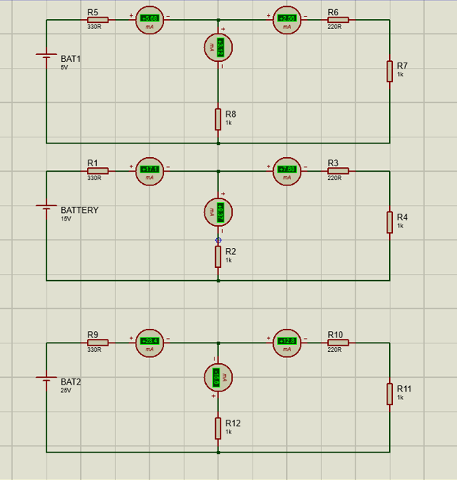

Experiment 2: Verification of KVL (Kirchhoff’s Voltage Law)

Objective
To verify Kirchhoff’s Voltage Law (KVL) by measuring voltages and showing that:
E1=V1+V2+V3

Theory
Kirchhoff’s Voltage Law states that the sum of all voltages in a closed loop is equal to the source voltage.

Procedure (Steps)
- Open Proteus software and create a new circuit.
- Place a DC Power Supply (RPS).
- Add resistors:
  - 330 Ω
  - 220 Ω
  - 1 kΩ
- Connect all resistors in the circuit as shown (loop form).
- Place voltmeters:
  - V1 across 330 Ω
  - V2 across 1 kΩ
  - V3 across 220 Ω
- Connect ground properly.
- Set supply voltage to:
  - 5V, run simulation and note V1, V2, V3
- Repeat for:
  - 10V
  - 15V
- Record all readings.

Calculations
Total resistance:
RT=330+1000+220=1550Ω

Current in circuit:
I=V/RT

Voltage drops:
V1=I×330
V2=I×1000
V3=I×220

Verification
E1=V1+V2+V3

Result
It is observed that the sum of voltage drops across all resistors is equal to the input voltage.
Hence, KVL is verified.

